POV Bike Wheel LED Display
Illustrated build guide — Wheel #1 (front wheel)
Qlife Racer · 26" wheel · Burning Man build

Parts you'll be working with
Lay these out before you start. Every part used in the steps below is shown here for reference.
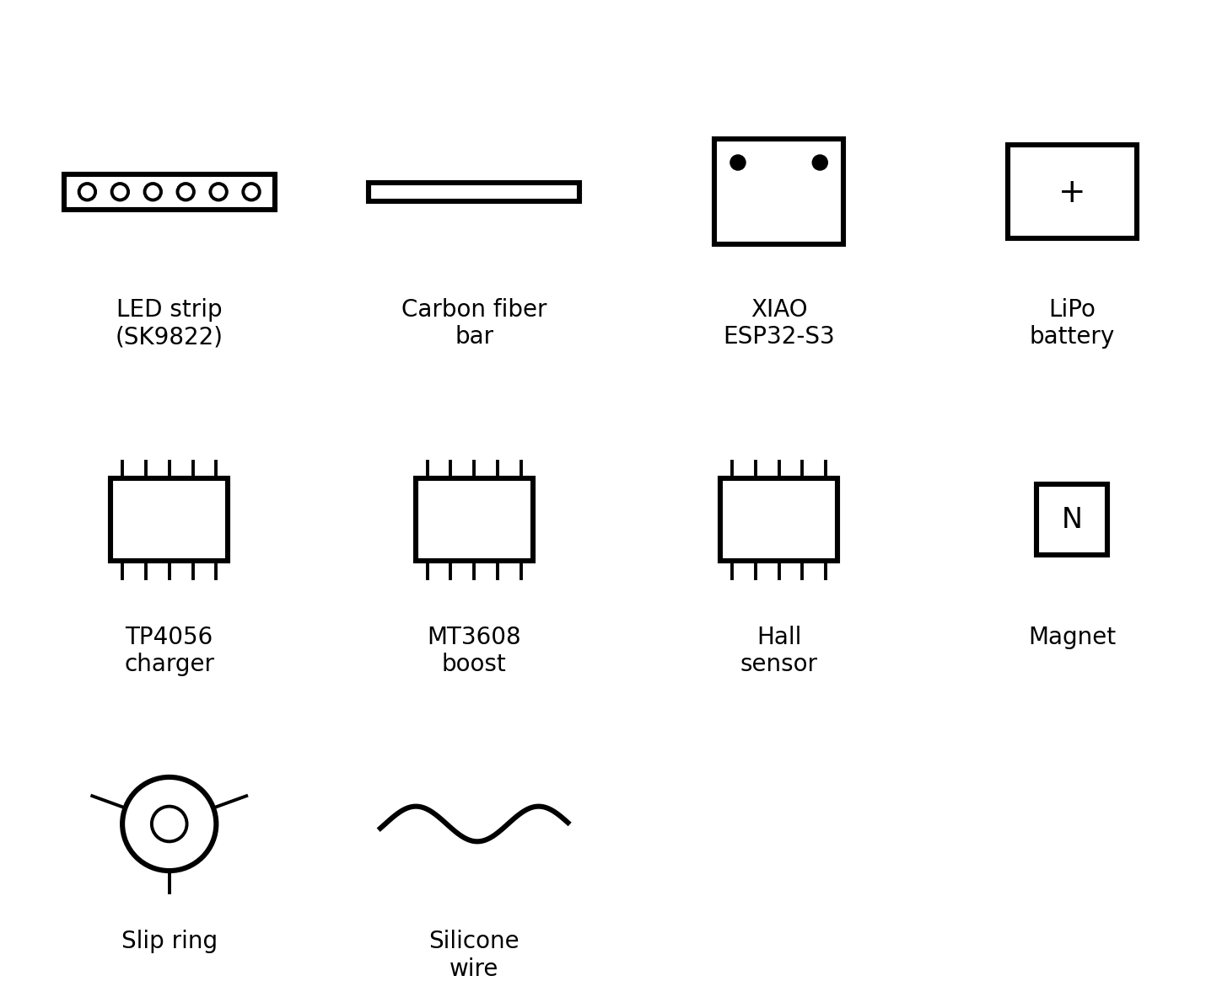
Figure 0 — full parts reference

Step 1 — Build the LED arm
Cut the carbon fiber bar to your spoke length (about 270mm for a 26" wheel). Cut the LED strip to match — only at the marked cut points.
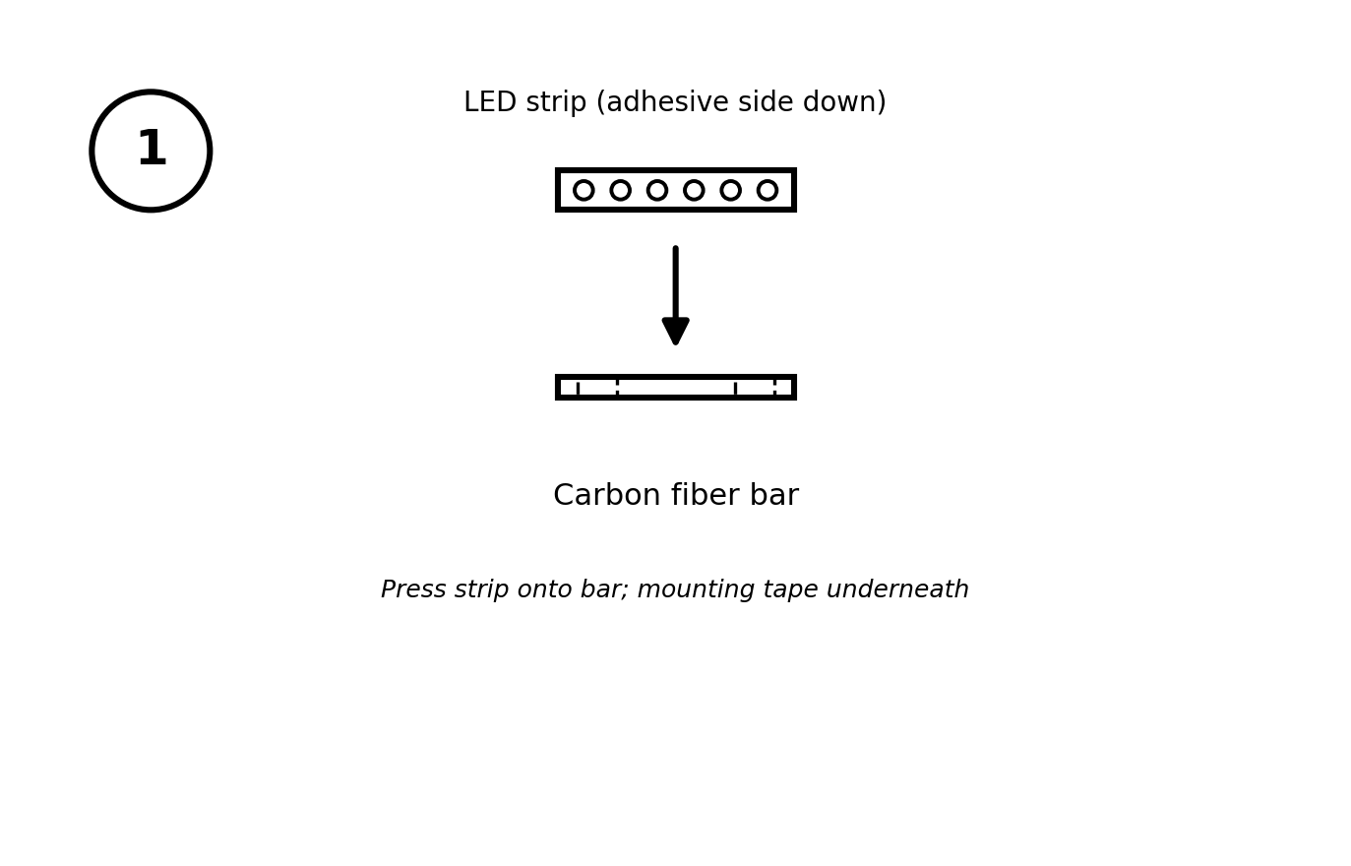
Figure 1 — press the LED strip onto the carbon fiber bar
- Clean the bar surface with isopropyl alcohol first
- Use the strip's adhesive backing plus extra double-sided tape for vibration resistance
- Leave the 4-pad data end exposed at the hub end — this connects to the XIAO

Step 2 — Wire the hub assembly
Wire and bench-test everything before it goes anywhere near the wheel. This is the step most builders skip and regret.
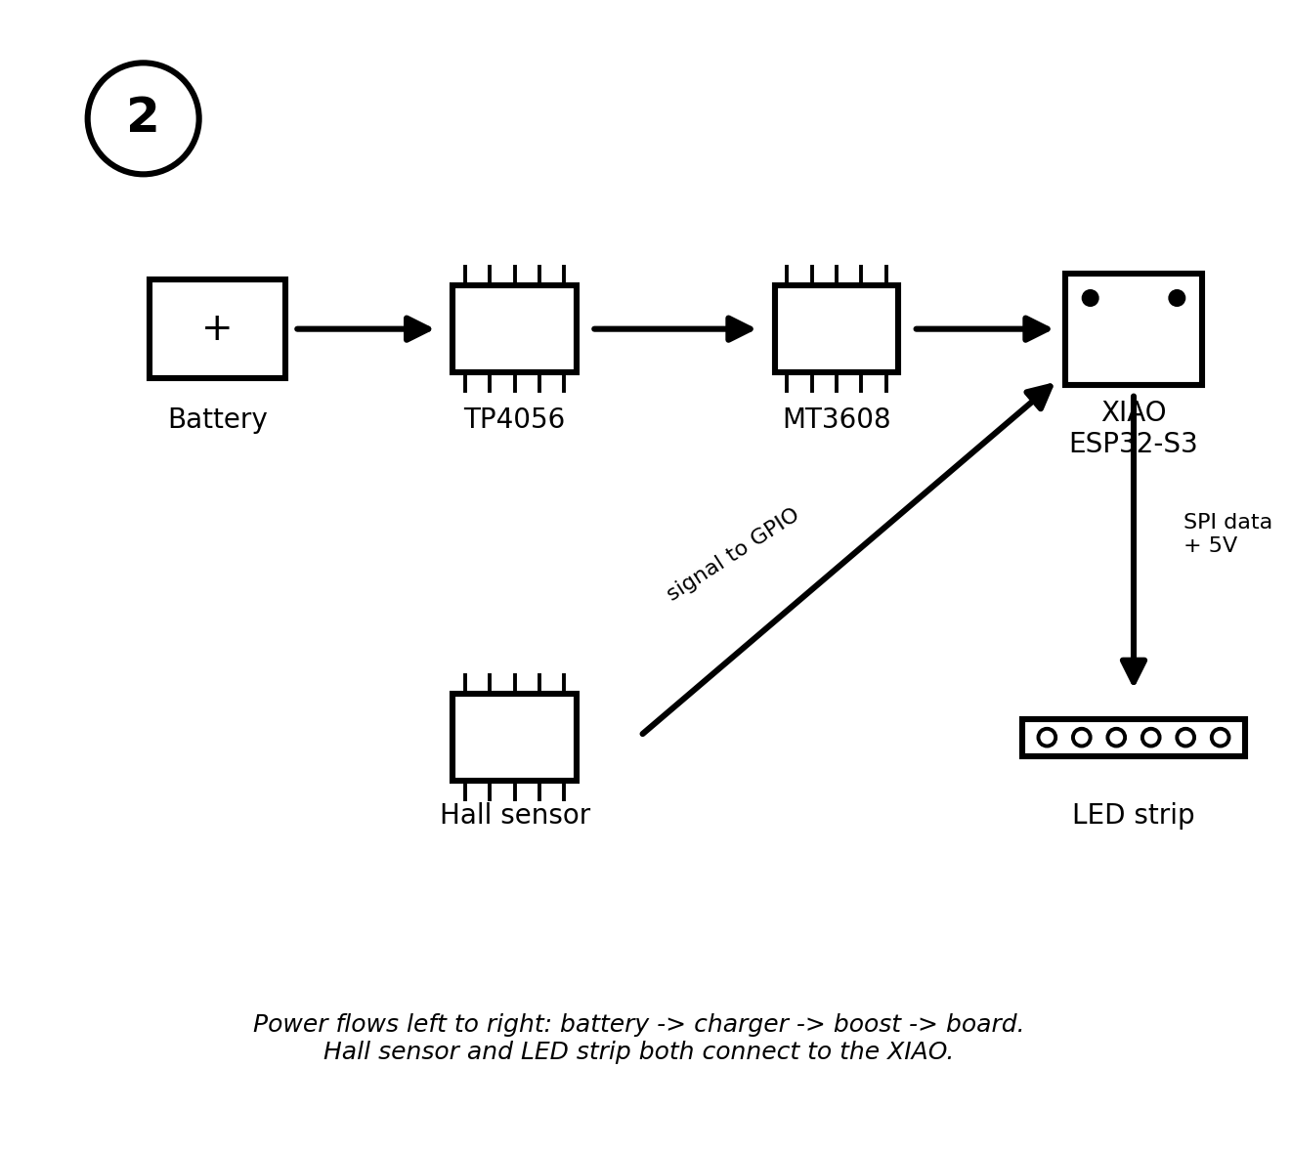
Figure 2 — power and signal flow
- Set the MT3608 output to exactly 5.0V with a multimeter before connecting anything
- LED strip gets its own direct 5V tap — do not route its power through the XIAO board
- Hall sensor OUT pin goes to a free GPIO pin configured as an interrupt

Step 3 — Hub enclosure layout
Before mounting anything to the wheel, plan the layout inside your hub enclosure. Three things need to be accessible from the outside without opening the enclosure: the rocker switch, the JST battery socket, and the TP4056 USB-C charging port.
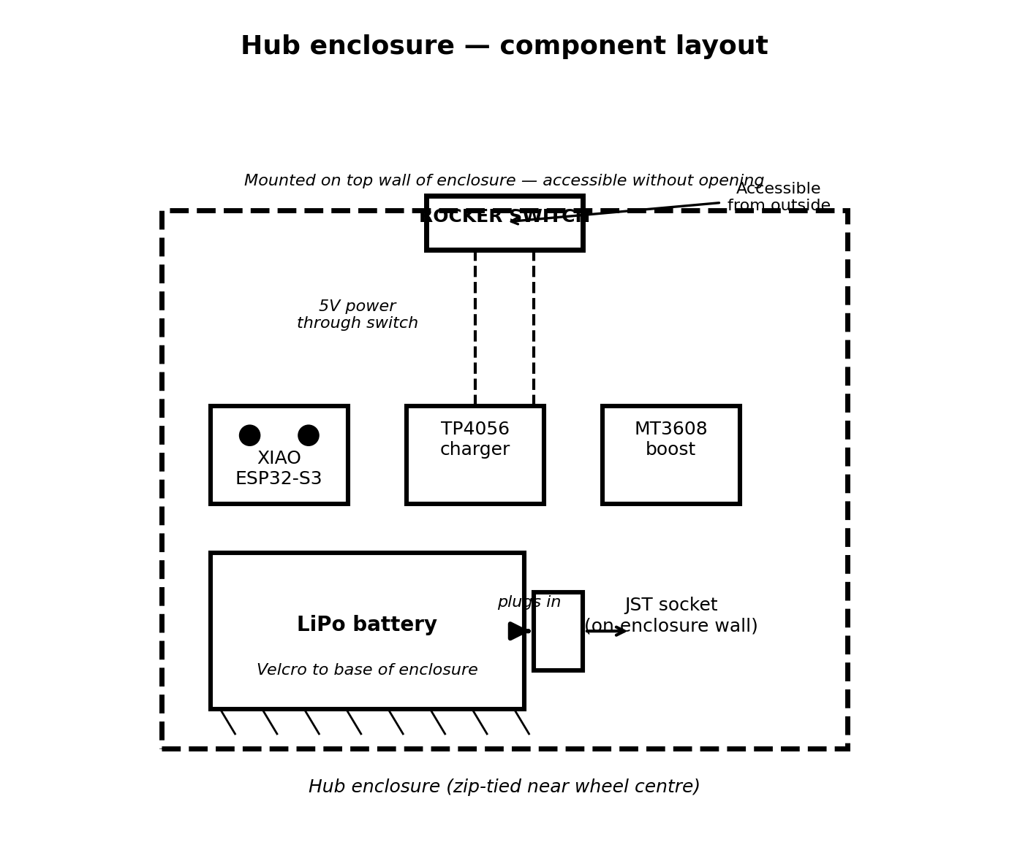
Figure 3 — hub enclosure component positions
- Rocker switch mounts on the TOP wall of the enclosure — you need to reach it while the bike is upright
- JST socket mounts on a SIDE wall — battery plugs in from outside, no tools needed
- TP4056 USB-C port should also face outward — so you can charge without removing the board
- Battery sits on the FLOOR of the enclosure, velcro'd in place — see Step 4
- XIAO, TP4056, and MT3608 boards sit above the battery on a small perf board platform

Step 4 — Mount the battery with velcro
Velcro is the right solution for the battery. It holds firmly during riding and vibration, but peels off cleanly for overnight charging. Do not glue or zip-tie the battery permanently.
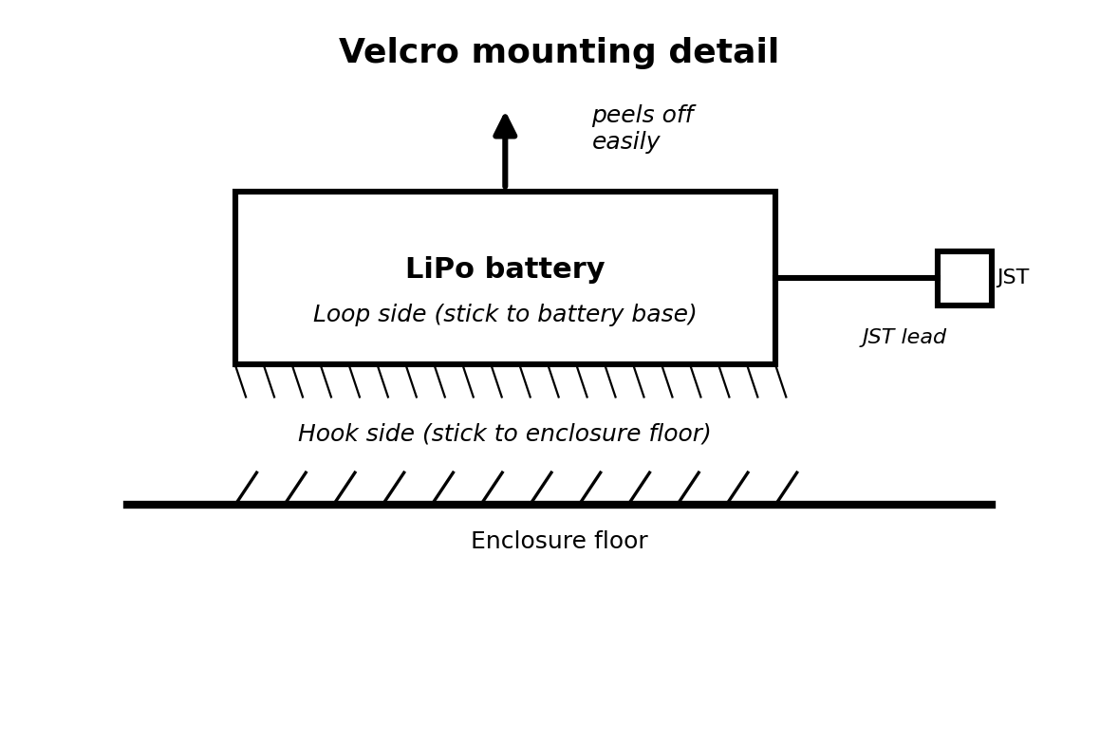
Figure 4 — velcro mounting detail
- Stick the HOOK side of the velcro to the enclosure floor
- Stick the LOOP side to the base of the LiPo battery
- Run the JST pigtail lead to the socket on the enclosure wall — leave enough slack to pull the battery up without straining the wire
- Press the battery down firmly — it will stay put at riding speed

Step 5 — Removing the battery for charging
Each night at camp, remove both wheel batteries and charge them while you sleep. The whole process takes under a minute per wheel.
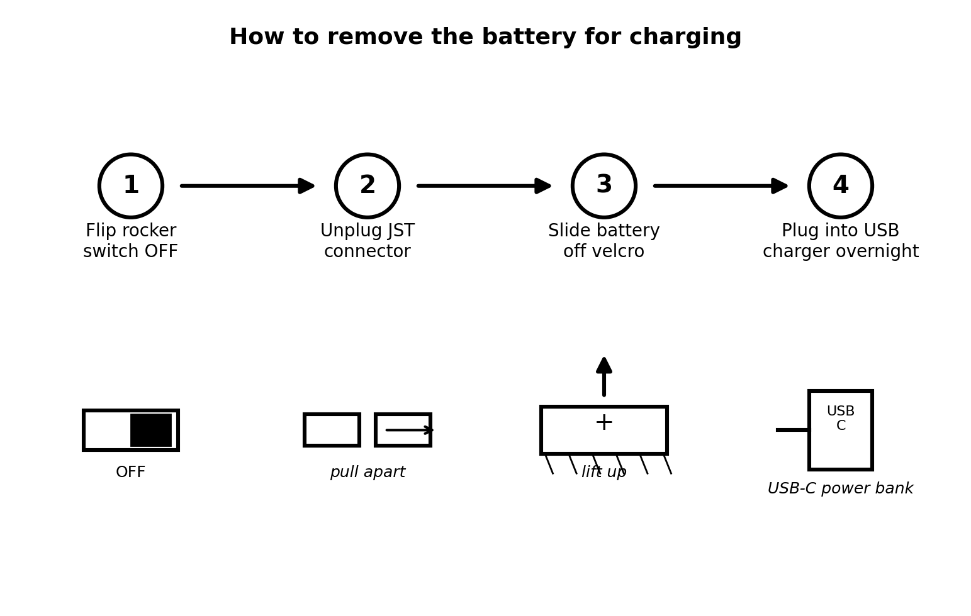
Figure 5 — four steps to remove and charge
- Step 1: Flip the rocker switch to OFF
- Step 2: Pull the JST connector apart — it clicks out cleanly
- Step 3: Peel the battery up off the velcro
- Step 4: Plug both wheel batteries into a USB power bank or camp power via a dual USB-C cable
Reinstall in reverse order in the morning. No tools required.

Step 6 — Mount the arm and enclosure to the wheel
Position the LED arm radially across two adjacent spokes and secure the hub enclosure near the centre.
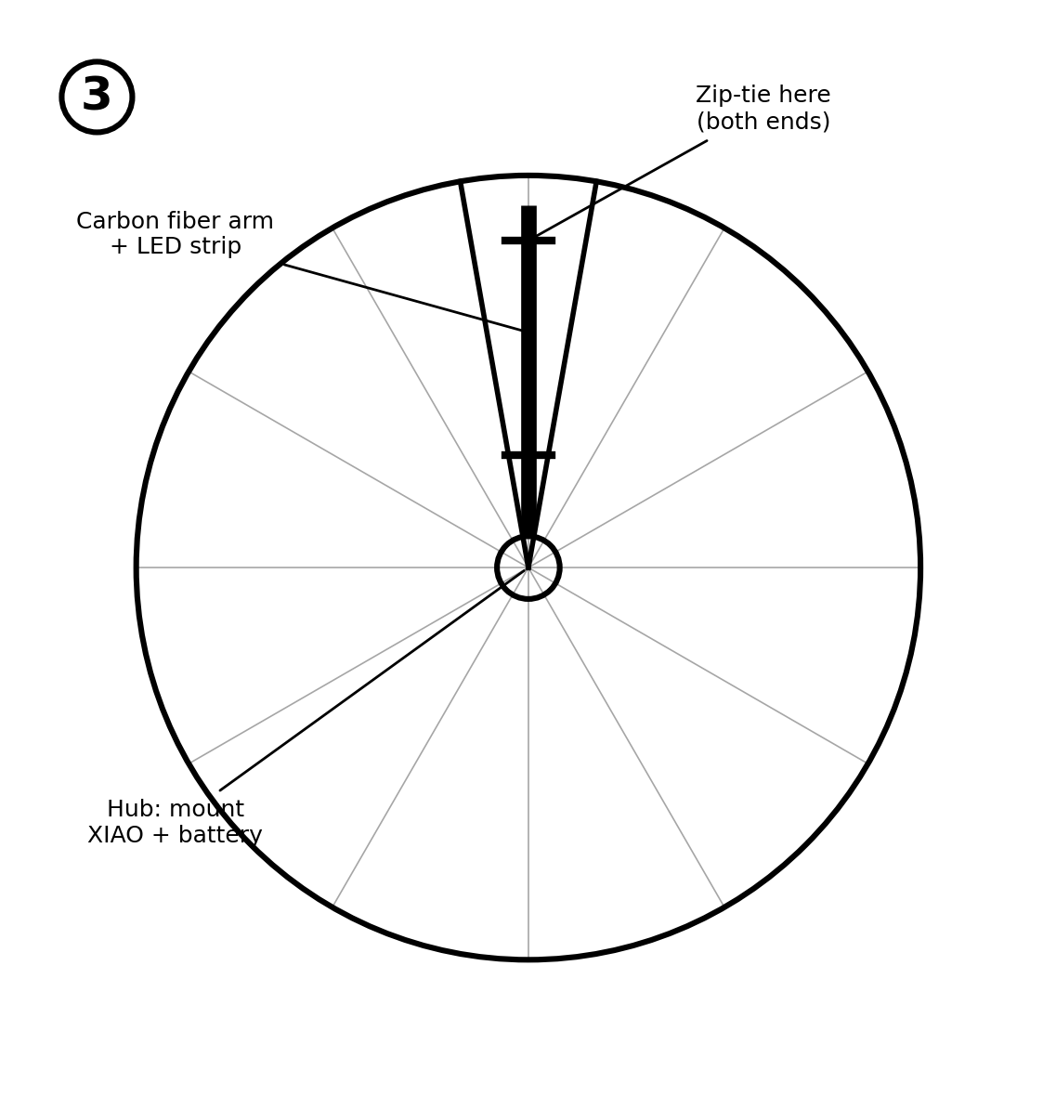
Figure 6 — arm position and hub mounting
- Zip-tie the arm to two spokes at both ends — snug, not overtightened
- Mount the enclosure as close to the hub as possible to minimise wheel imbalance
- The rocker switch and JST socket should face outward, away from the spokes

Step 7 — Align the hall sensor and magnet
The magnet stays on the fork (stationary). The sensor rides on the wheel arm and passes it once per rotation.
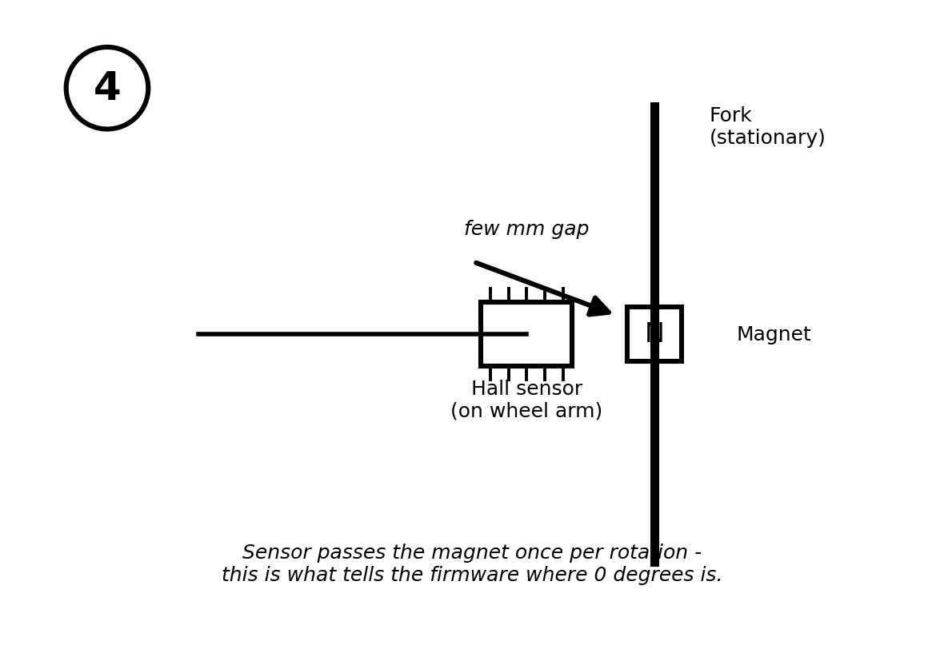
Figure 7 — sensor and magnet gap
- Keep the gap to a few millimetres for a reliable trigger
- Spin the wheel by hand and confirm the sensor passes the magnet consistently every rotation

Step 8 — First spin test
Flash MicroPython, run a hall-sensor test, then a solid-colour LED test, then the full POV firmware. Test with the wheel off the ground before any road test.
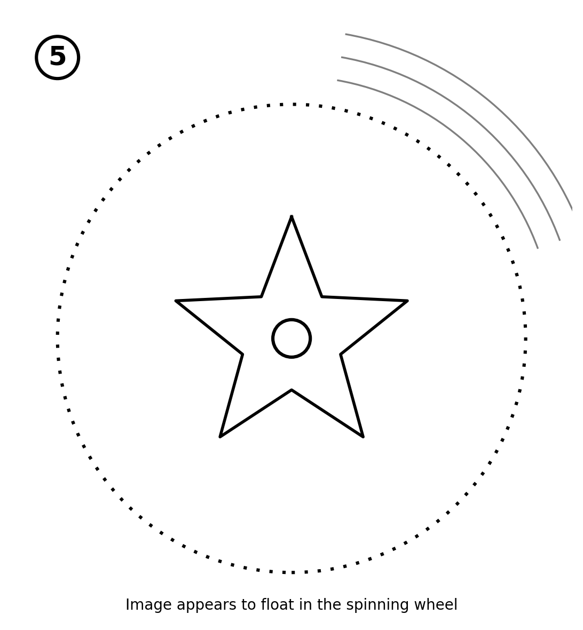
Figure 8 — the goal: a stable image floating in the spinning wheel
- Blurry or smeared image = column timing needs adjustment
- Once the stationary test looks clean, do a slow ride in an empty car park before normal riding

Next steps
Once wheel #1 is fully tested and riding reliably, repeat Steps 1-8 for the rear wheel. Apply MG Chemicals 419D conformal coating as the final weatherproofing step before Burning Man — only after everything is tested and working.

